**GIT AND GITHUB CONFIGURATION.**

**G**

**IT**

* **The purpose of Git is to manage a project, or a set of files, as they change over time.**
* **Git stores this information in a data structure called a repository.**
* **Git repository is just a file location where you are storing all the files related to your project.**

**G**

**ITHUB**

* **GitHub** is a hosting service for Git repositories.
* **GitHub** is the **service for projects that use Git**.
* **GitHub is a web-based Git repository hosting service, which offers all of the distributed revision control**
* **Source Code Management (SCM) functionality of Git as well as adding its own features.**

**GIT And GITHUB Setup**

**Get a**[**github**](https://github.com/)**account.**

* + **Go to www.github.com and signup your github ...**
  + **Now Open Your Linux Terminal And type these Commands To access Your Github account On your local machine**
  + **Install Git On Your Linux Machine**
  + **apt install git then follow steps given below:**

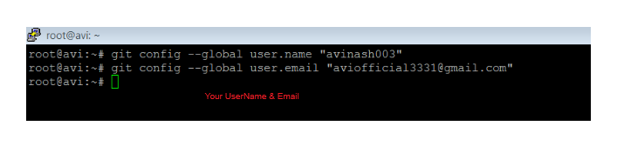

* + - * + **Go to your github account and create a repository with a name "mygit" By Simply clicking on New Repository**
        + **And Then Follow These Steps:**

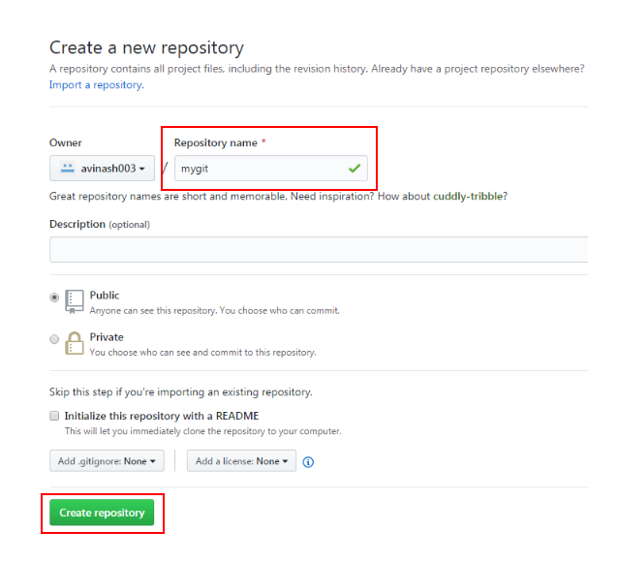

* **Git will provide you some Quick Setup Guide that makes Git so easy please have some look on it..**

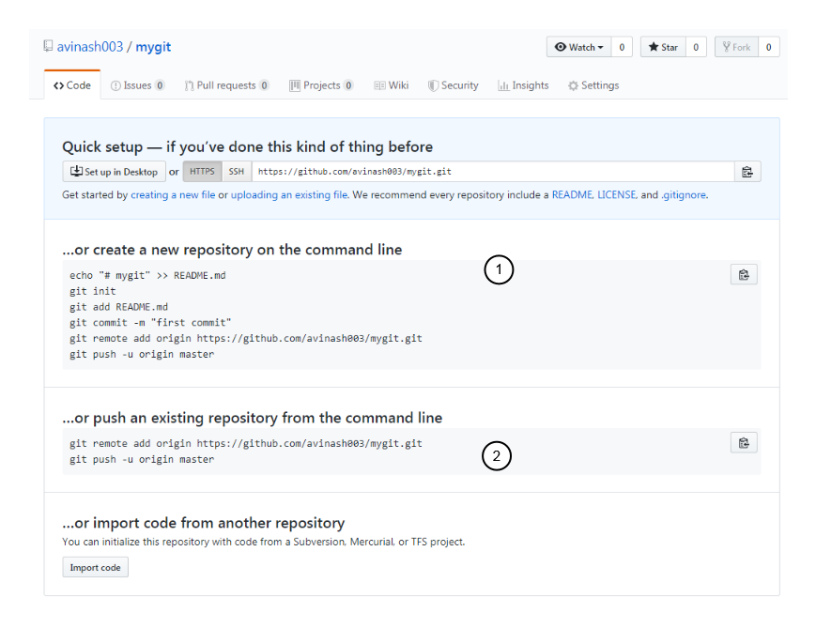

**Now**

**Initialized Repo From GitHub To Your Local Machine And Push Some text To Your GitHub Follow these Steps:**

* + - * **Open Terminal**
      * **cd /home/avi # Open Directory Where You Want To initialized your git repo**
      * **mkdir mygit # Make a Dir Of Same name Which You created on GitHub**
      * **git init # this is usually the first command you'll run in a new project**
      * **cd mygit # open mygit**
      * **touch new.txt # create a text File**
      * **git add new.txt # Add this file to git**
      * **git commit -m "** **First Repo " # make A comment On it**
      * **git remote add origin https://github.com/avinash003/mygit.git # Get Remote Access Of Your Git Repo**
      * **git push -u origin master # Push Text File To Your Master Branch**
      * **Username for 'https://github.com': avinash003 # Enter Your Git User Name**
      * **Password for 'https://avinash003@github.com':************* # Enter Git Password**

## 

* **Now we Are going to pull a File from github To our Local Machine:**
* **Click On Create New File Button**
* **Name the file And Then Click on Commit new file**
* **To Pull the file On Local Machine open The terminal And Follow These steps:**

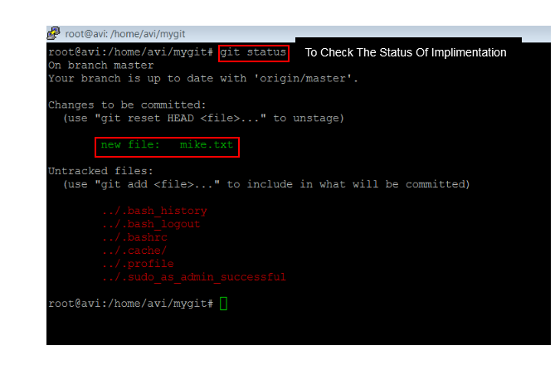

### You Can see The new Implement Of File through This Command

* **Now Type Git Pull to Download Or Pull Your file from Your GitHub Branch**

